Rip plz help/edit/correct things

## Answer 1

P5, 6, 7 of the Asset price dynamics slides

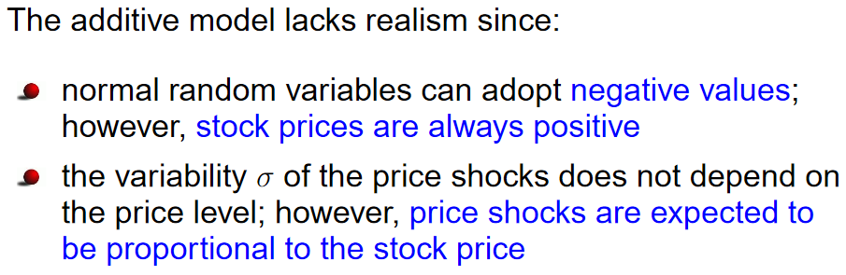

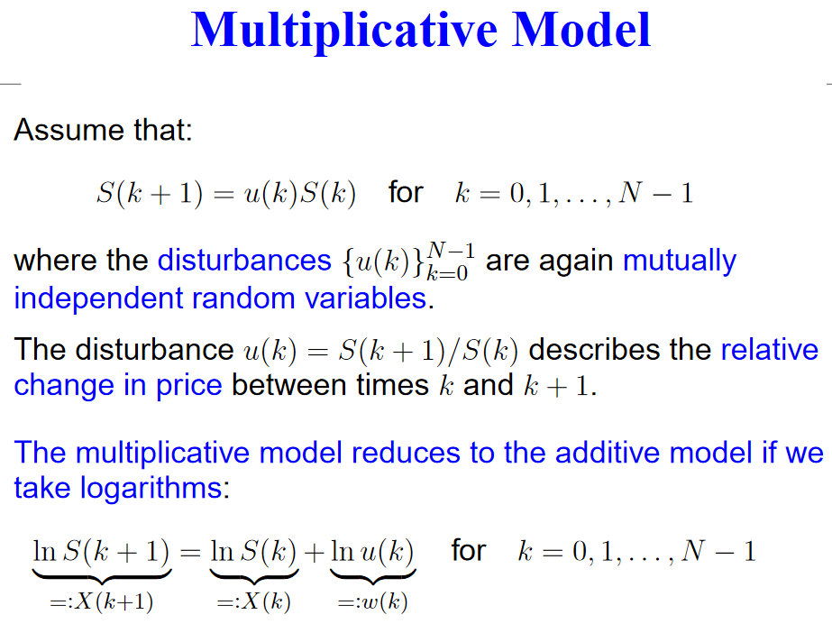

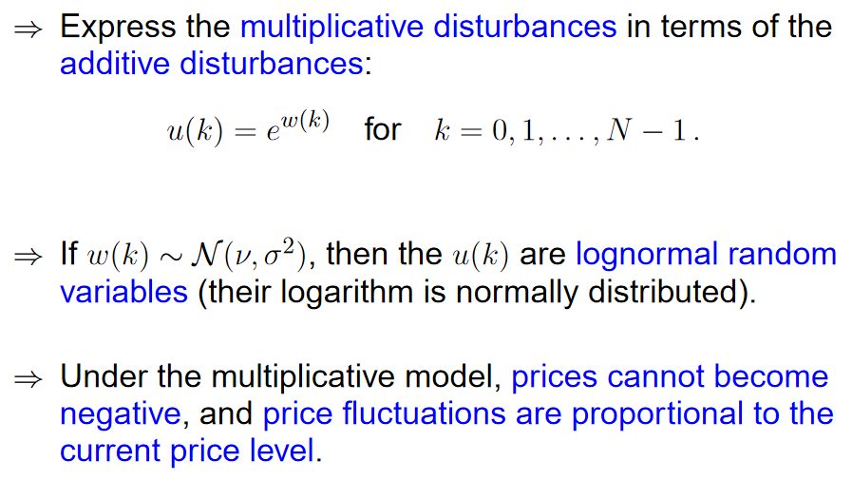

1. Tut 8 exercise 1 (tut shows model for 1 year instead of 6 months), can also use exact formula from slides

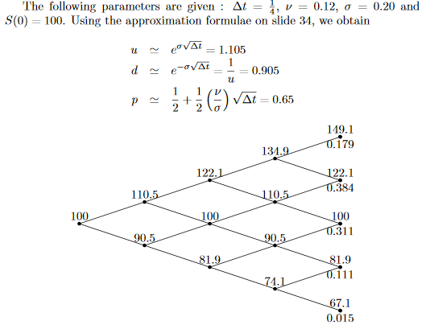

1. Tut 8 exercise 2

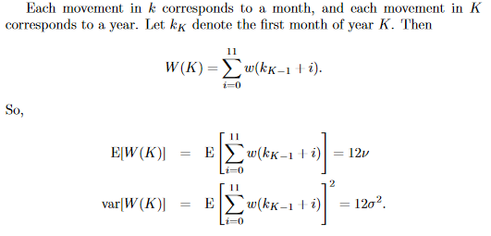

## Answer 2

1. P38 of Basic Options theory

American call is never exercised early.

As for American put, early exercise is optimal

1. Tut 9 exe
2. rcise 5

## Answer 3

1. A, b, x >0 and all real numbers

0 < x <= a/b since the utility function needs to be strictly increasing w

1. Risk-averse: U is strictly concave in x and strictly increasing, here a,b > 0 and 0 < x <= a/b

Risk-neutral: we need to have U(x) = x hence b = 0, a whatever

Risk-seeking: U(x) should be convex, which leads to b <0

1. aE[y] - ½ bE[y]^2 is constant in Markowitz model so maximising utility = minimising variance

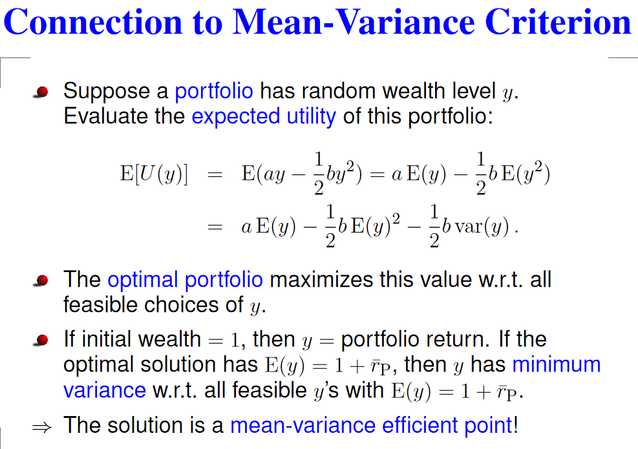

## Answer 4

[https://mycourses.](https://mycourses.aalto.fi/pluginfile.php/200078/mod_folder/content/0/Solutions6.pdf?forcedownload=1)aalto.fi/pluginfile.php/200078/mod_folder/content/0/Solutions6.pdf?forcedownload=1 see page

A little context on what is going on. We are considering a portfolio of the efficient $w_{0}$ and an arbitrary portfolio $w_{1}$, and looking at the sum of their variances. We then differentiate them to find the minimum variance. After that, the trick is to set $α=0$– this is because we want to set the minimum variance which is only possible when we give everything to the optimal asset. Set it to zero and the rest falls apart very quickly.

5 for Q4 answers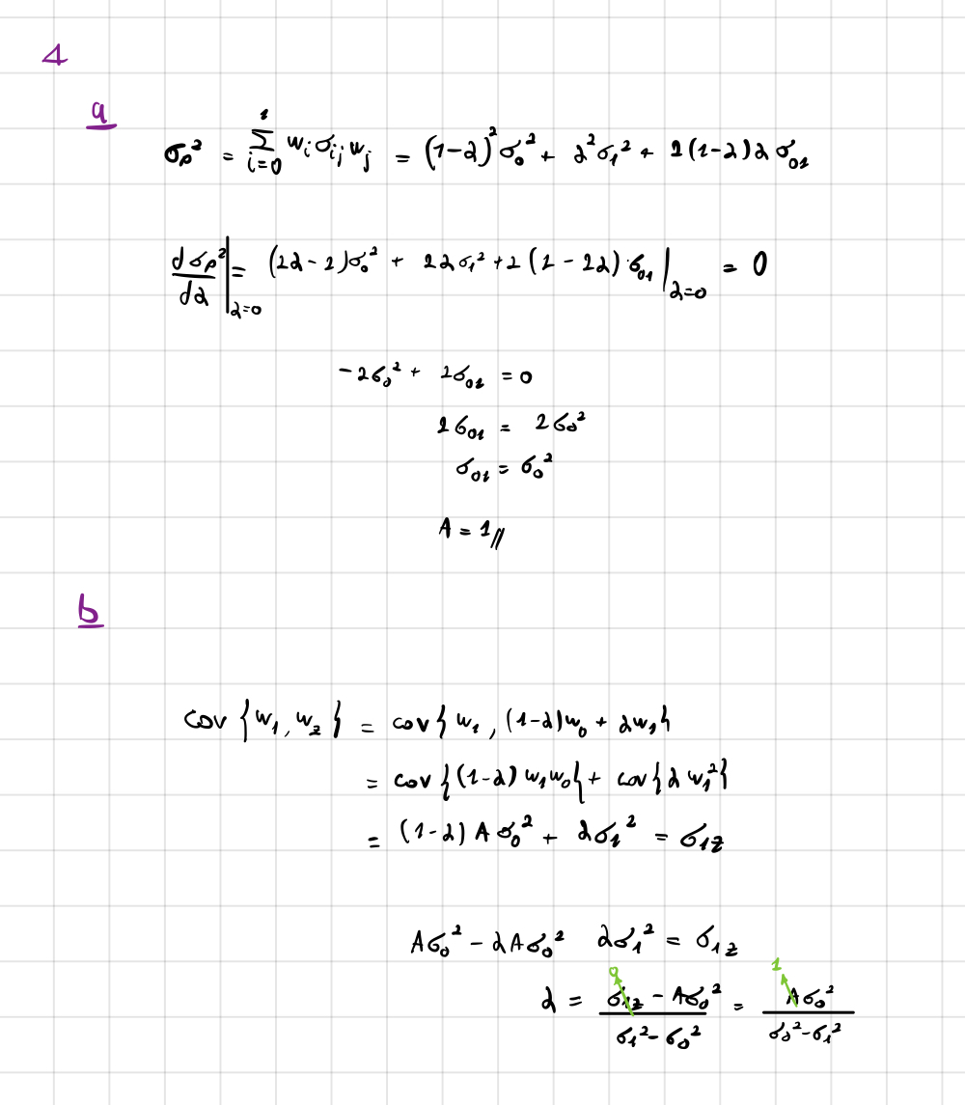

4d) 0.19 (different to the link above)

This can easily be done by first finding $cov(i, m)$ using the formula for correlation:

$$corr\left(i, m\right)=\frac{cov\left(i, m\right)}{σ_{i}σ_{m}}$$

This gets us

$$\frac{1}{2}=\frac{cov\left(i, m\right)}{\frac{3}{20}×\frac{1}{2}} \\ cov\left(i, m\right)=\frac{3}{80}$$

Then, use the CAPM formula:

$$β_{im}=\frac{{\overline{r}}_{i}-\overline{r_{z}}}{\overline{r_{m}}-\overline{r_{z}}} \\ \frac{\frac{3}{80}}{{\left(\frac{3}{20}\right)}^{2}}=\frac{\overline{r_{i}}-0.09}{0.15-0.09}$$

(as $β_{im}=\frac{cov\left(i,m\right)}{σ^{2}m}$)

This gets us $$\overline{r}=0.06\left(\frac{\frac{3}{80}}{{\left(\frac{3}{20}\right)}^{2}}\right)+0.09=0.19$$